Performance and Growth
User Guide for Employees and Managers
[Organization name]
[Version / date]

For HR teams: This guide is designed to be edited. Replace the placeholders in square brackets, remove any sections that don’t apply to your organization, and add your own contacts, dates and review processes before sharing it with your people. Screenshots show example data.
Contents

Note: If the contents list appears empty, right-click it in Word and choose Update Field.

1. About this guide
Performance and Growth brings goals, feedback, 1:1 meetings and performance reviews together in one place on your intranet. This guide explains how to use each area, step by step, with screenshots.

Who this guide is for
- Employees: everything you need to set goals, give and receive feedback, take part in 1:1 meetings and complete your self-assessment.
- Managers: everything above, plus Team Goals and completing manager reviews for the people who report to you. Manager-only steps are marked with a green “For managers” box.

Other ways to learn
Short help videos are available for each area of Performance and Growth. [Add links to your help videos here.] If you have questions, contact [HR contact name and email].

Key terms
Term | Meaning
Goal | Something you want to achieve, with a due date, priority and progress.
Key result | A measurable outcome that shows progress toward a goal.
Feedback | Praise, recognition or constructive comments shared with a colleague.
1:1 meeting | A regular one-to-one conversation between a manager and an employee.
Review cycle | A review period set up by HR, such as a quarterly or 90-day onboarding review.
Self-assessment | Your own reflection on your performance, completed before your manager’s review.
Manager review | Your manager’s ratings and comments, completed alongside your self-assessment.

2. Getting started
Open Performance & Growth from the main menu of your intranet. Along the top you’ll see the areas you can use:
- Dashboard: your goals, progress and any open review at a glance.
- My Goals: create and track your goals.
- Team Goals: (managers only) see how your team’s goals are tracking.
- Feedback: give, request and view feedback.
- Reviews: complete your self-assessment and view your reviews.
- 1:1 Meetings: schedule and track one-to-one meetings.

Your dashboard
The dashboard is the first page you see. It highlights anything that needs your attention.
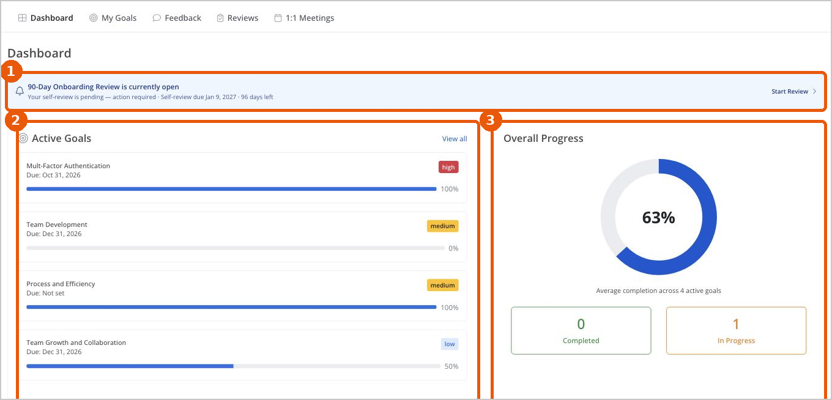
Figure 1: The Performance and Growth dashboard
1 Review banner: appears when a review is open for you. Select Start Review to begin your self-assessment.
2 Active Goals: your current goals with their due dates, priority and progress. Select View all to open My Goals.
3 Overall Progress: the average completion across your active goals.

3. My Goals
My Goals is where you create, track and update your goals. Each goal shows its status, progress, due date, number of updates and key results.
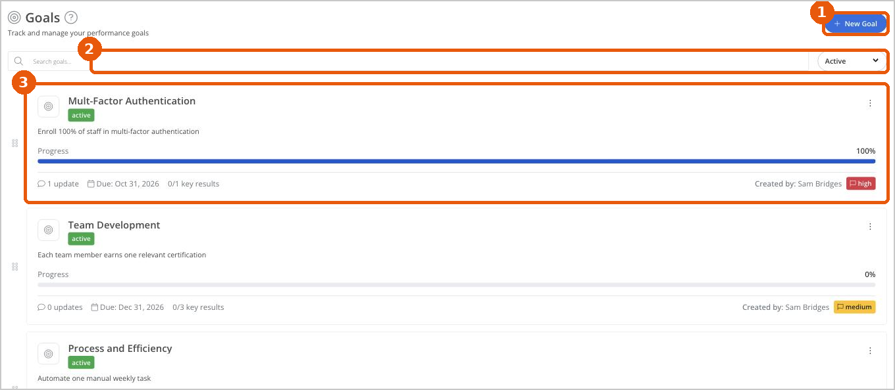
Figure 2: The My Goals page
1 New Goal: create a new goal.
2 Search and filter: find a goal by name, or filter by status (for example, Active).
3 Goal card: shows progress, updates, due date, key results, who created it and its priority. Select a goal to see its details.

Create a goal
- Go to My Goals and select New Goal.
- Enter a Goal Title that clearly describes what you want to achieve.
- Check Assign To. Your name is added automatically.
- Add a Description explaining why the goal matters and what success looks like.
- Choose a Priority (Low, Medium, High or Critical) and a Status.
- Scroll down to set the start and due dates, and add key results so progress can be measured.
- Select Save.
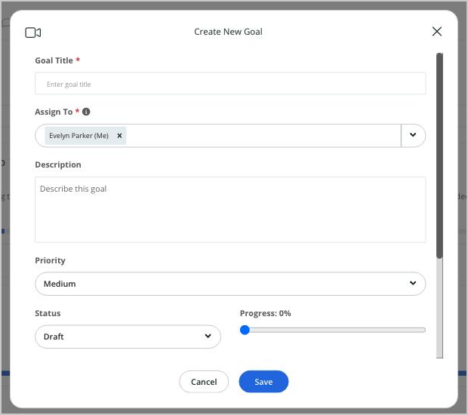
Figure 3: Creating a new goal
Tip: Good goals are specific and measurable. For example, “Reduce customer onboarding time from 30 to 14 days” is clearer than “Improve onboarding”.

View goal details
Select a goal to open its details, including progress, owner, description, dates and key results. Select Edit Goal to make changes.
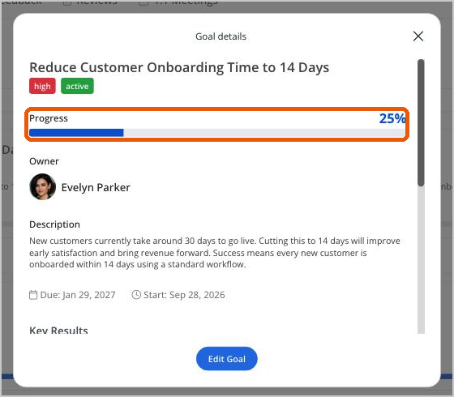
Figure 4: Goal details

Update your progress
- On the goal card, open the menu (⋮) and choose to update progress.
- Drag the Progress slider to the new percentage.
- Add Update Notes describing what’s changed, what’s next and anything blocking you.
- Select Save. The update is added to the goal’s history.
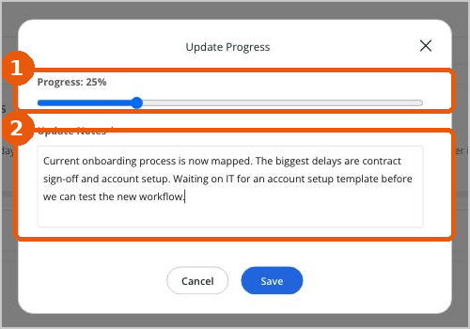
Figure 5: Updating progress on a goal
1 Progress: the new completion percentage.
2 Update Notes: a short summary of what has changed. This field is required.
Tip: Regular updates keep your manager informed and make your next 1:1 or review conversation much easier.

4. Team Goals (managers)
For managers: Team Goals is only visible to managers. It shows goals for the people who report to you.
At the top of the page you’ll see your number of direct reports, total goals, average progress and completed goals. Team Goal Health shows how many goals are On Track, At Risk or Overdue.
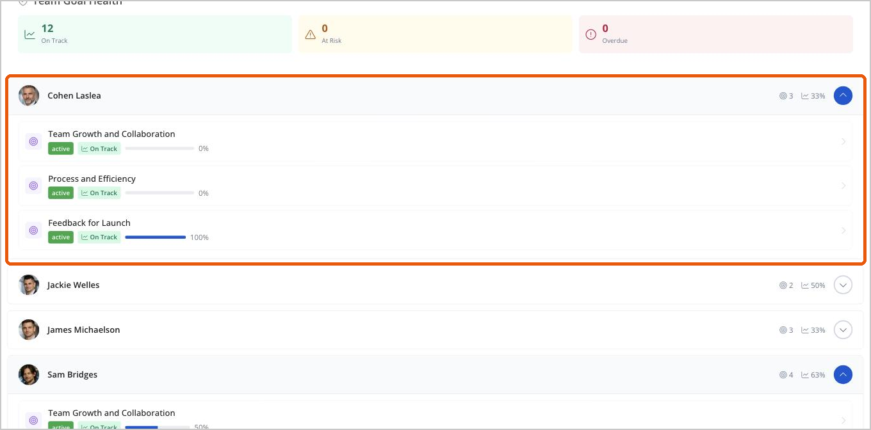
Figure 6: Team Goals, with one team member expanded
- Go to Team Goals.
- Select a team member to expand their goals. Each goal shows its status and progress.
- Select a goal to open its details, including the description, dates and key results.
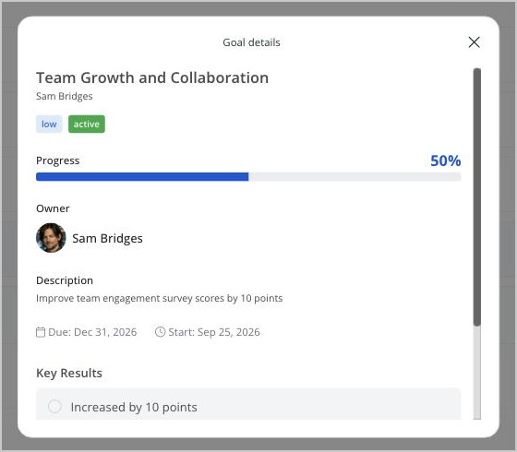
Figure 7: Goal details for a team member
Tip: Use Team Goal Health to spot goals that are at risk or overdue, and raise them in your next 1:1.

5. Feedback
Feedback helps people understand what’s working well and what could be done differently, throughout the year rather than only at review time.
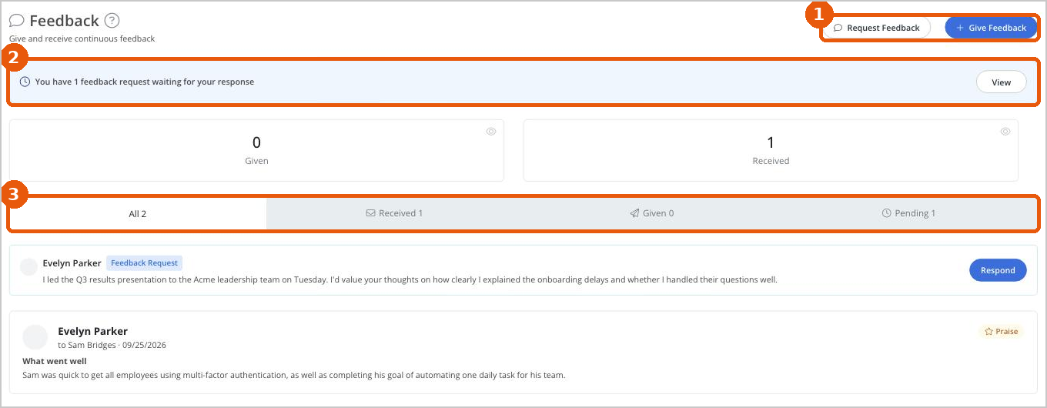
Figure 8: The Feedback page
1 Request Feedback and Give Feedback: start a new request or share feedback.
2 Waiting requests: a banner shows when a colleague has asked you for feedback.
3 Tabs: view All, Received, Given or Pending feedback.
Note: Feedback is only seen by the recipient and their manager. It is not made public or seen by anyone else.

Give feedback
- Go to Feedback and select Give Feedback.
- Choose the Recipient.
- Choose a Type: Praise, Recognition, Constructive, Request or Other.
- Complete the required text. The questions change to suit the feedback type, such as “What worked well?” for praise or “What could be improved?” for constructive feedback.
- Optionally, select the Company Values the person demonstrated and attach a file.
- Select Send Feedback.
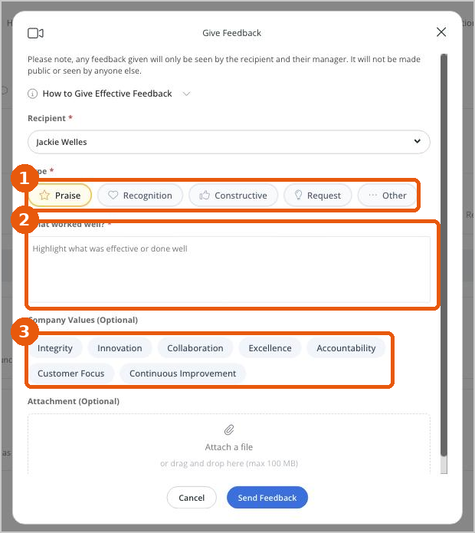
Figure 9: Giving feedback
1 Type of feedback.
2 Your feedback. Be specific about what happened and why it mattered.
3 Company Values (optional).
Tip: Open How to Give Effective Feedback in the form for guidance and examples for each feedback type.

Request feedback
- Select Request Feedback.
- Under Request Feedback From, choose one or more colleagues.
- Describe the specific work or situation you’d like feedback on.
- Optionally, attach a file, then select Send Request.
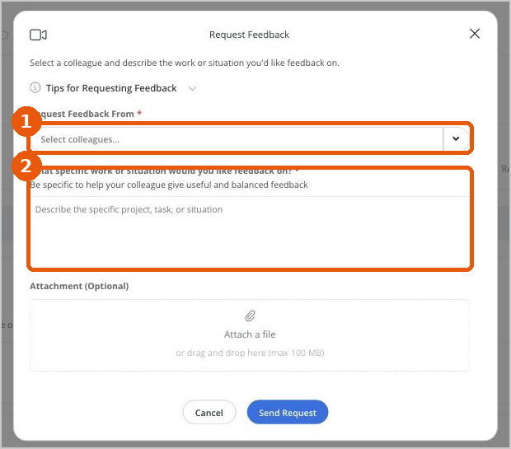
Figure 10: Requesting feedback

Respond to a feedback request
When someone asks you for feedback, it appears at the top of your Feedback page and in the Pending tab.
- Select Respond next to the request.
- Read the request at the top of the form.
- Complete What went well? and What could be done differently?
- Optionally, select the company values demonstrated, then select Send Feedback.
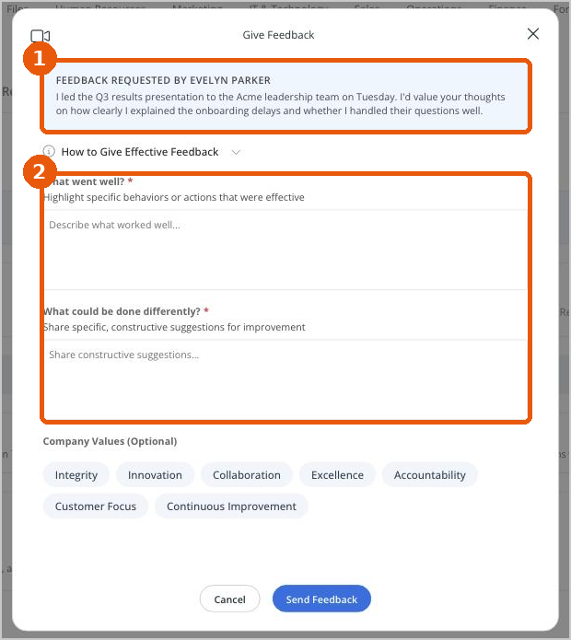
Figure 11: Responding to a feedback request

6. 1:1 Meetings
1:1 Meetings help managers and employees keep regular conversations on track, with agendas, goals to discuss, notes and actions in one place.
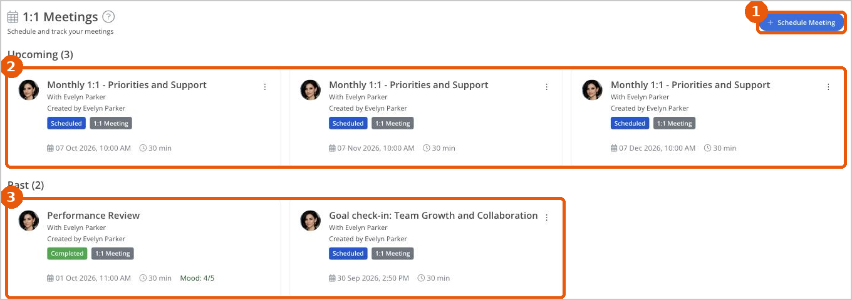
Figure 12: The 1:1 Meetings page
1 Schedule Meeting: set up a new meeting.
2 Upcoming: scheduled meetings.
3 Past: earlier meetings, including the mood rating for completed ones.

Schedule a meeting
- Go to 1:1 Meetings and select Schedule Meeting.
- Enter a Title and choose who the meeting is With.
- Choose the meeting Type, Date & Time and Duration.
- Optionally, add a Location and Video Call Link.
- To repeat the meeting, select Set up recurring meetings, then choose the Frequency and End Date.
- Add Agenda items, and select any Goals to Discuss.
- Select Schedule.
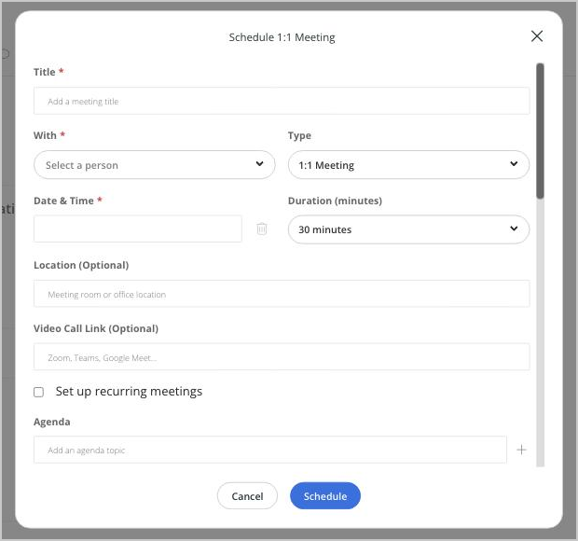
Figure 13: Scheduling a 1:1 meeting
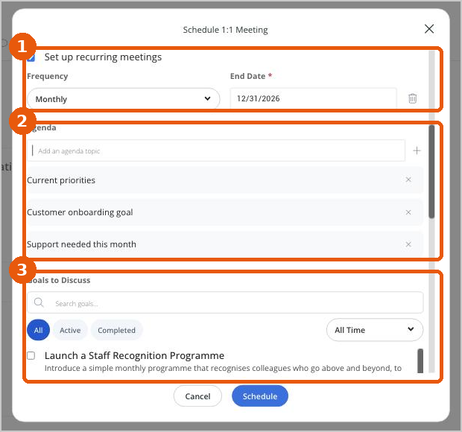
Figure 14: Recurring meetings, agenda and goals to discuss
1 Recurring meetings: frequency and end date.
2 Agenda: add topics one at a time.
3 Goals to Discuss: link goals so you can review progress together.

View and complete a meeting
Select a meeting to see its details, agenda and goals to discuss. Select Edit to make changes, or Mark Complete once the meeting has taken place.
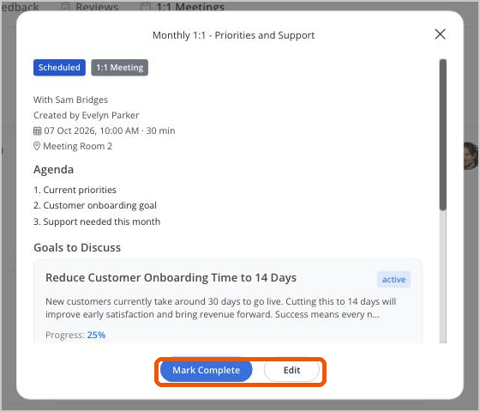
Figure 15: Meeting details
- Select Mark Complete.
- Rate How did the meeting go? from 1 to 5.
- Add any Final Notes, such as agreed actions.
- Select Complete. The meeting moves to Past and shows its mood rating.
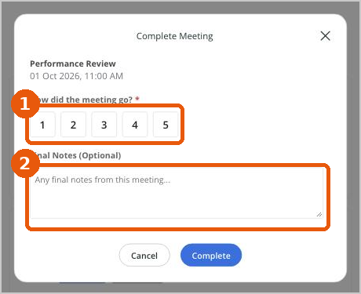
Figure 16: Completing a meeting

7. Performance Reviews
Performance reviews bring together your own reflection and your manager’s evaluation, as the basis for a productive conversation about performance and development.

How a review works
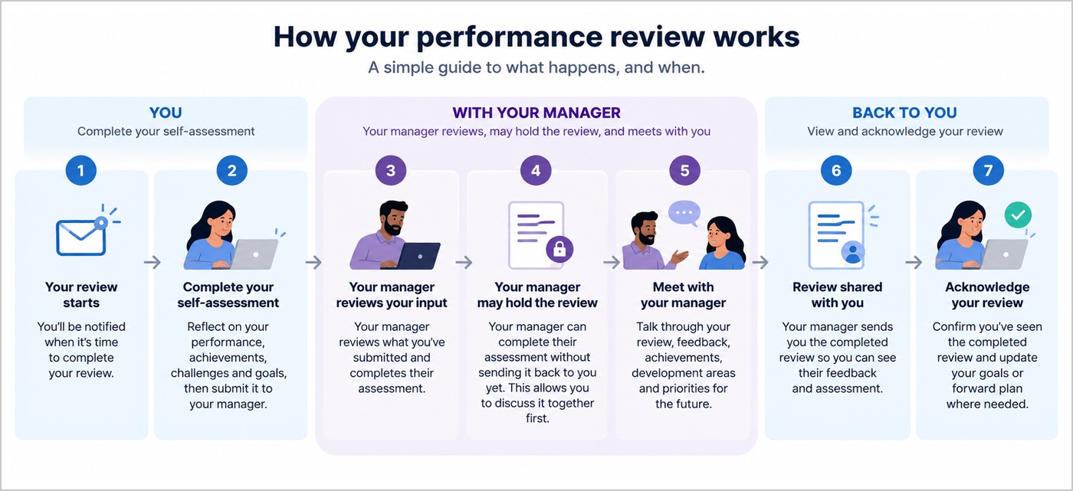
Figure 17: The review process from start to finish
- You: you’re notified when your review starts, then you complete and submit your self-assessment.
- With your manager: your manager reviews what you submitted and completes their assessment. They may hold the review until you’ve discussed it together.
- Back to you: your manager sends you the completed review. You view it, update your forward plan if needed, and acknowledge it.

The Reviews page
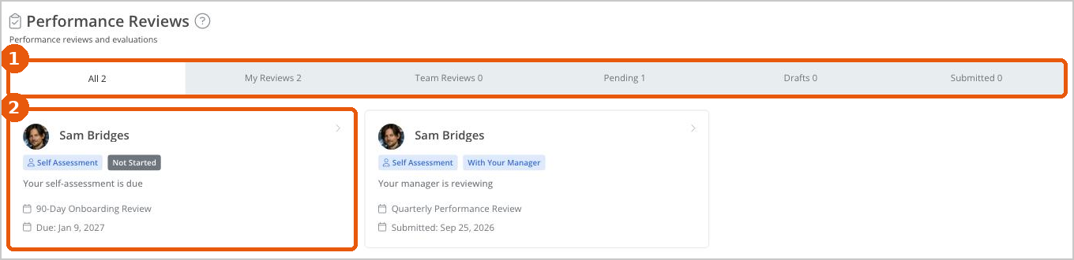
Figure 18: The Reviews page
1 Tabs: All, My Reviews (your own), Team Reviews (managers), Pending (still outstanding), Drafts (started and saved) and Submitted.
2 Review card: shows the review type, status, a plain-English message about what happens next, the review cycle and due or submitted dates.
See Review statuses in section 8 for what each status means.

Complete your self-assessment
Open your self-assessment from the dashboard banner (Start Review) or by selecting the review card on the Reviews page.
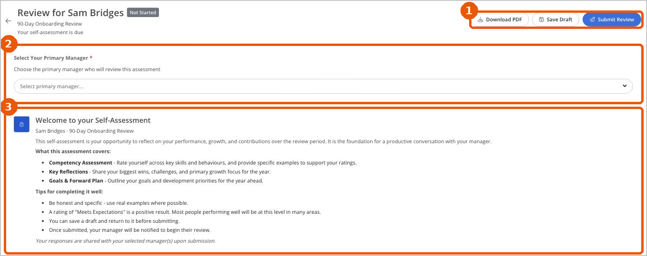
Figure 19: The top of the self-assessment
1 Download PDF, Save Draft and Submit Review.
2 Select Your Primary Manager: the person who will review your assessment.
3 Welcome: what the assessment covers, and tips for completing it well.

Step 1: Confirm your manager
Choose your primary manager from the list. Your submitted self-assessment goes to this person, and appears in their Team Reviews.
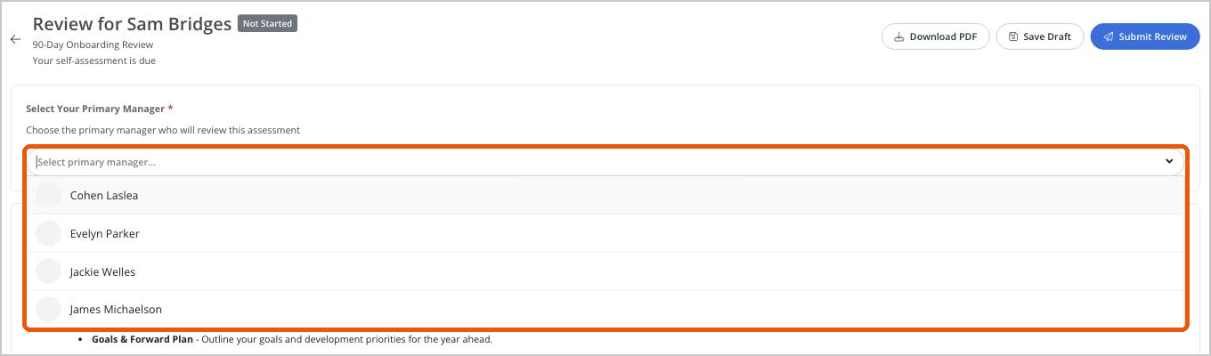
Figure 20: Selecting your primary manager
Note: If the right person isn’t listed, contact [HR contact] before you submit.

Step 2: Choose goals and feedback to discuss
Select the goals and feedback you’d like to discuss with your manager. Only the items you select are visible to your manager in this review. Select the eye icon to view an item before deciding.
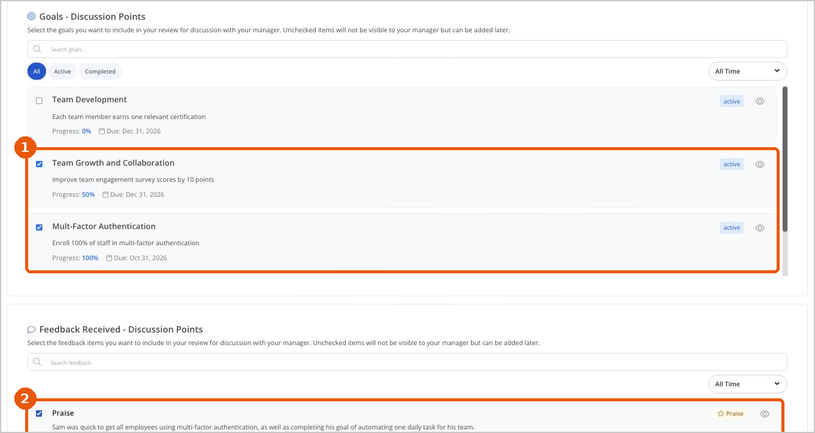
Figure 21: Selecting goals and feedback as discussion points
1 Goals - Discussion Points: tick the goals to include.
2 Feedback Received - Discussion Points: tick the feedback to include.

Step 3: Rate each competency
- For each competency, drag the slider to your rating, from Poor to Outstanding.
- Open Rating Guide to see what each rating means.
- In Employee’s Comments, explain your rating with specific examples.
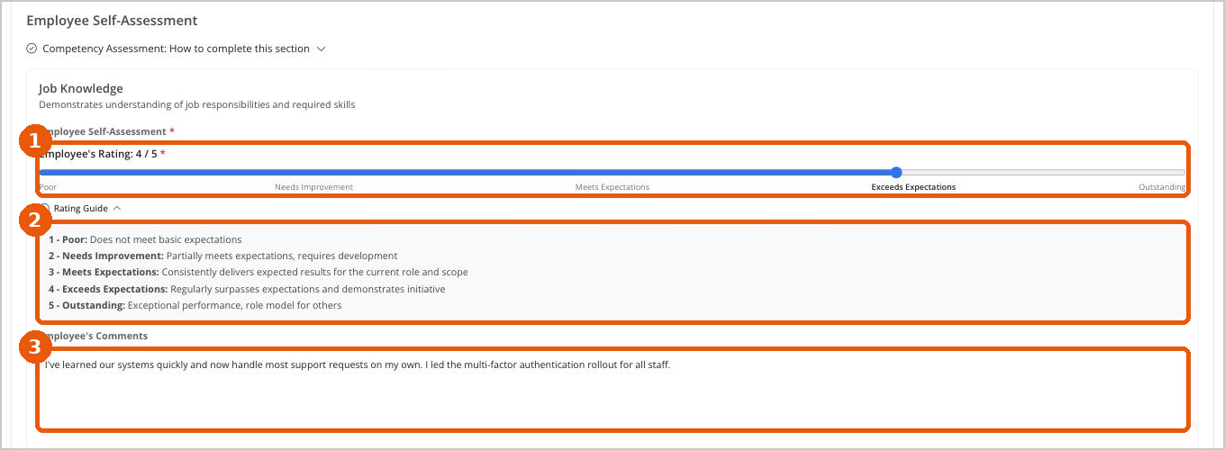
Figure 22: Rating a competency, with the Rating Guide open
Tip: “Meets Expectations” is a positive result. Most people performing well will be at this level in many areas. Use comments to give examples rather than relying on the rating alone.

Step 4: Reflect on the review period
Your Overall Rating is calculated automatically from your competency ratings. Then answer the Key Reflection Questions: key wins, key challenges, your primary growth focus and the support you need.
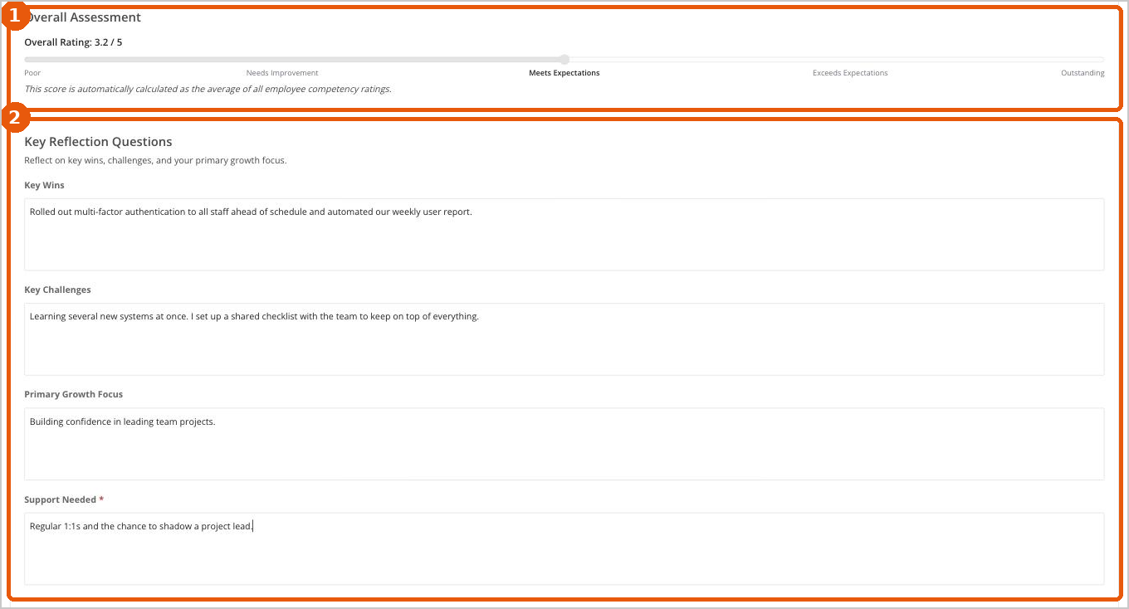
Figure 23: Overall rating and key reflection questions
Note: The sections and questions in your review depend on the template your organization uses, so they may differ slightly from the screenshots.

Step 5: Plan ahead
In Goals & Forward Plan, outline your annual goals, near-term focus for the next one to two quarters, and development goals. You’ll discuss these with your manager.
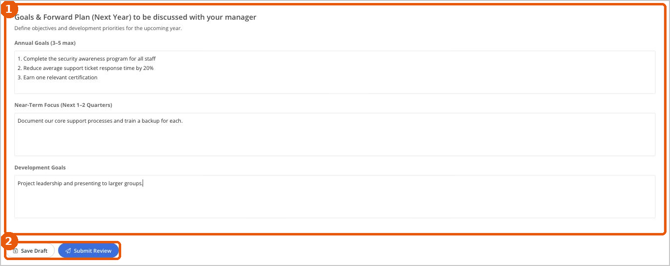
Figure 24: Goals and forward plan, with the Save Draft and Submit Review buttons

Step 6: Save or submit
- Save Draft: saves your work so you can come back later. The review shows as In Progress and appears in the Drafts tab.
- Submit Review: sends your self-assessment to your manager. The review shows as Submitted, with the message “Waiting for your manager’s review”.
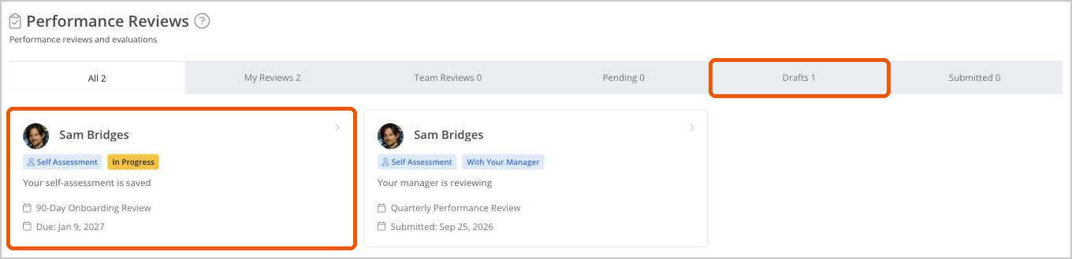
Figure 25: A saved draft shows as In Progress
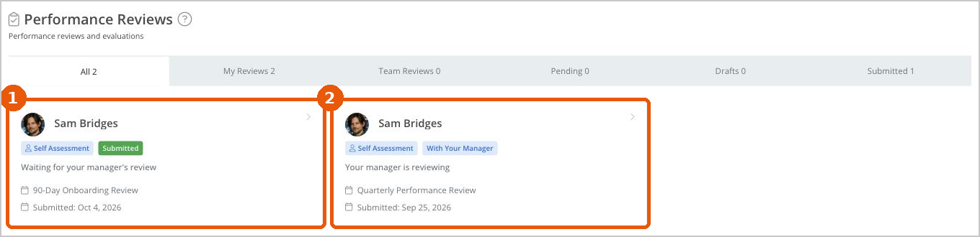
Figure 26: After submitting, the review shows as Submitted. Once your manager starts reviewing, it shows as With Your Manager.
Important: Check your answers before you select Submit Review. Your manager is notified as soon as you submit.

Review conversation guide
Every review includes a Review Conversation Guide with suggested questions for the review conversation: one set for managers to ask employees, and one for employees to ask managers. Expand it to prepare for your discussion.

Complete a manager review (managers)
For managers: When someone who has selected you as their manager submits their self-assessment, it appears in your Team Reviews tab with the status Awaiting Manager Review.
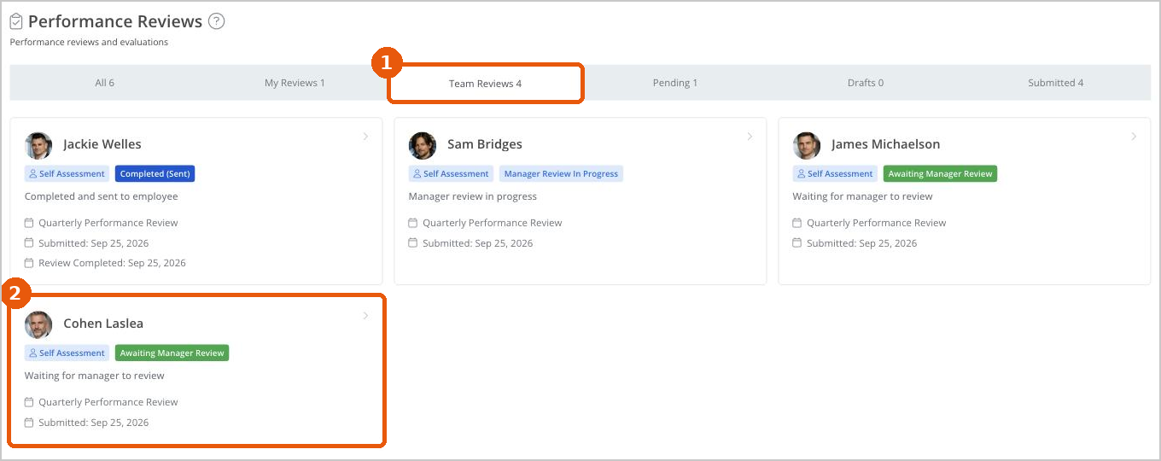
Figure 27: A submitted review in Team Reviews
- Go to Reviews and select the Team Reviews tab.
- Select the review to open it. You’ll see the employee’s selected goals and feedback, ratings, comments, reflections and forward plan.
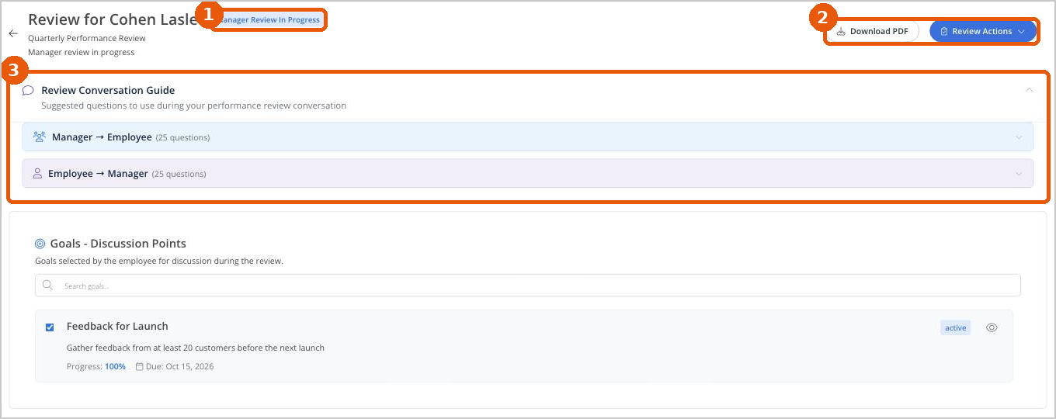
Figure 28: Opening a team member’s review
1 Status: changes to Manager Review In Progress.
2 Download PDF and Review Actions.
3 Review Conversation Guide: suggested questions for your conversation.

Rate each competency
For each competency, you’ll see the employee’s rating and comments above your own Manager Assessment. Drag the slider to your rating and add Manager Comments.
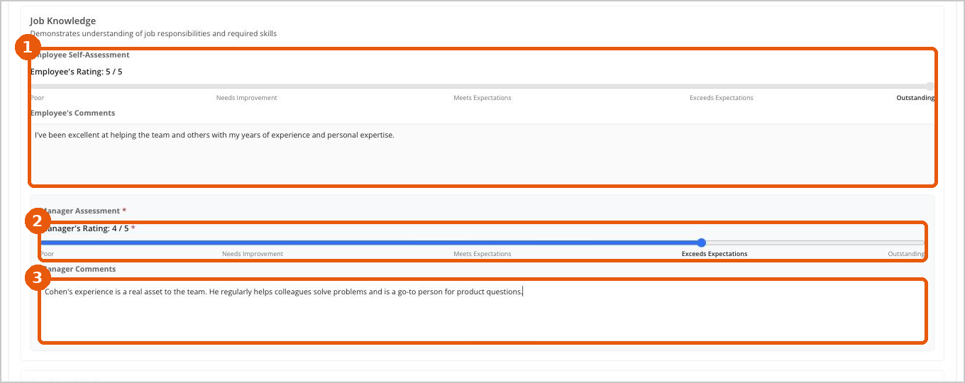
Figure 29: Employee and manager ratings side by side
1 The employee’s self-assessment.
2 Your rating.
3 Your comments.
Tip: Ratings won’t always match. A difference isn’t automatically a problem. It’s a useful starting point for a conversation about expectations, evidence and development.
Both overall ratings are calculated automatically from the competency ratings.
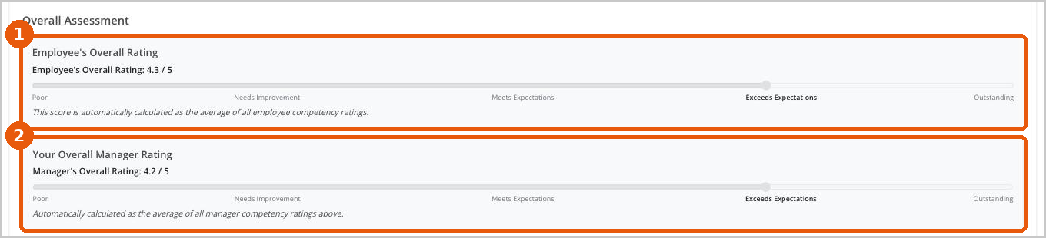
Figure 30: The employee’s and manager’s overall ratings

Write your summary
In Manager Review Summary, bring together the key themes: strengths, development priorities and the main points you want to discuss.
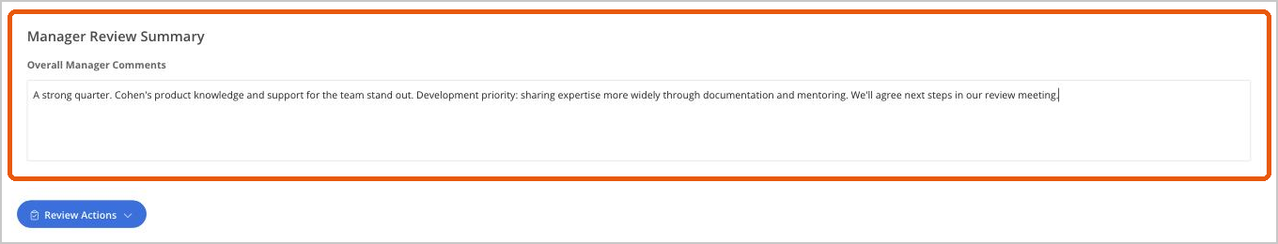
Figure 31: The manager review summary

Save, hold or send
Select Review Actions (at the top or bottom of the review) and choose one of the following:
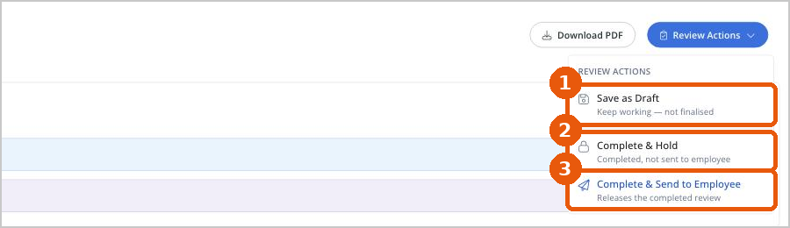
Figure 32: Review Actions
Action | What it does | When to use it
Save as Draft | Saves your work without finalizing the review. | You want to come back and finish later.
Complete & Hold | Marks your assessment as complete, but doesn’t send it to the employee yet. | You want to discuss the review face to face before releasing it.
Complete & Send to Employee | Releases the completed review to the employee. | You’ve finished and are ready for the employee to see it.

Receive your completed review
When your manager sends your review, you can see your self-assessment and your manager’s evaluation together. The status changes to Completed (Sent).
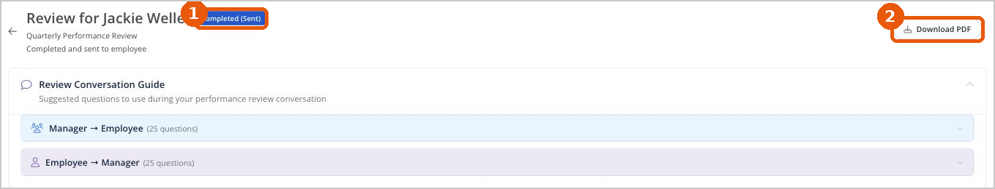
Figure 33: A completed review
1 Status: Completed (Sent).
2 Download PDF: save a copy of the completed review.
For each competency, you’ll see your rating and comments alongside your manager’s. This shows where your perspectives align, and where there may be something useful to discuss.
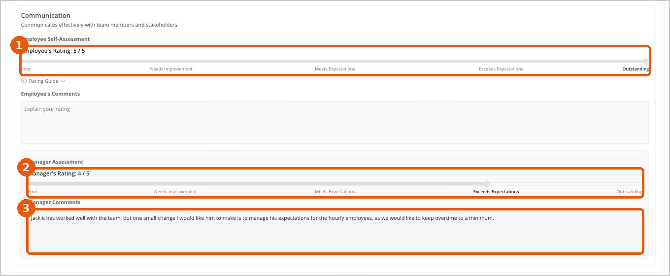
Figure 34: Comparing your rating with your manager’s

Update your forward plan
After your review conversation, update your Goals & Forward Plan to reflect what you agreed. This turns the review into a practical plan for what happens next.

Acknowledge your review
- Read the completed review and have your review conversation with your manager.
- Update your forward plan if needed.
- Select Acknowledge Review.
Acknowledging records that you’ve seen the completed review, and brings the review to its final stage.
For HR teams: [Optional: add a screenshot of the Acknowledge Review button here.]

Download your review as a PDF
Select Download PDF at the top of any review to save a copy for your records.

8. Quick reference

Review statuses
Status | What it means
Not Started | Your self-assessment is due and hasn’t been started yet.
In Progress | Your self-assessment has been saved as a draft but not submitted.
Submitted | You’ve submitted your self-assessment and it’s waiting for your manager’s review.
Awaiting Manager Review | What managers see when a team member has submitted and the manager hasn’t started their review.
With Your Manager / Manager Review In Progress | Your manager is completing their review.
Held | Your manager has completed their review but hasn’t released it to you yet, usually so you can discuss it first.
Completed (Sent) | Your manager has completed the review and sent it to you.

Rating scale
Rating | Meaning
1 – Poor | Does not meet basic expectations.
2 – Needs Improvement | Partially meets expectations, requires development.
3 – Meets Expectations | Consistently delivers expected results for the current role and scope.
4 – Exceeds Expectations | Regularly surpasses expectations and demonstrates initiative.
5 – Outstanding | Exceptional performance, role model for others.

Frequently asked questions
Do I have to complete my self-assessment in one go?
No. Select Save Draft at any time and come back later. Your review will show as In Progress.
Who can see the feedback I give?
Only the recipient and their manager. Feedback is not made public.
Will my manager see all of my goals and feedback in my review?
No. Only the goals and feedback you select as discussion points are visible to your manager in that review.
What do the red asterisks mean?
Fields marked with an asterisk (*) are required.
My manager isn’t listed when I select my primary manager. What should I do?
Contact [HR contact] before you submit your self-assessment.
My manager rated me differently from my own rating. Is that a problem?
Not necessarily. Differences are a normal part of the process and a good starting point for your review conversation.
Where can I find a completed review later?
Go to Reviews and select My Reviews. Open the review and select Download PDF to keep a copy.
Who sets up review cycles and templates?
Your HR team. Contact [HR contact] with any questions about review dates or the questions in your review.

Need help?
Contact [HR contact name, email and phone]. [Add links to help videos or your intranet help pages here.]

